Increment 1 and 2

Created a new file called idGenerator that
- Can be called as a function
  - To be called during new database entry form (e.g. new user signup, when user clicks 'submit')
- Takes target table as parameter (e.g. 'users')
- Generates random 8 character base64 string from alphabet
  - As regex: /A-Za-z0-9_-/{8}
  - ca. 270 trillion unique combinations
- Checks to see if string already exists as ID in table
  - yes → generates new string and checks again
  - no → returns string
the code:
import pool from './db-connection.js';

const char = "ABCDEFGHIJKLMNOBQRSTUVWXYZabcdefghijklmnobqrstuvwxyz0123456789";

function idGenerator() {
let id = "";
for (let i = 0; i < 8; i++){
//Math.random() returns a float between 0 and 1 eg. 0,5 then we multiply it
//by the length of char to get a number between 0 and char.length = 62 and we floor it
//to get a whole number.
//so we randomly pick a character between index 0 and 61
id += char.charAt(Math.floor(Math.random() * char.length));
}
return id;
}

//returns true if id is taken in the table
async function isIdTaken(table, id) {
//send an sql query to check if id exists in the table
const [rows] = await pool.query(`SELECT * FROM ?? WHERE id = ?`, [table, id]);
return rows.length > 0; // true if conflict exists
}

//retun a unique id for the table
async function generateUniqueId(table) {
let uniqueId;
let isTaken = true;
//keep generating ids until we find one that is not taken
//isTaken turns false if theres no conflict
while (isTaken) {
uniqueId = idGenerator();
isTaken = await isIdTaken(table, uniqueId);
}
return uniqueId;
}

export default generateUniqueId;

and implemented the function in the backend (server) and now we use the new table I created User.
app.post("/api/signup", async (req, res) => {
try {
const { username, email, password } = req.body;

if (!username || !email || !password) {
return res.status(400).json({ error: "Missing required fields" });
}

const salt = await bcrypt.genSalt();
const encPass = await bcrypt.hash(password, salt);
//here we use the new Tabel User that i created in the database
//generate unique id 8 char string for the users table and check for conflicts
//and resolvem them by regenerating
const table = "User";
const userID = await generateUniqueId(table);

let result;
try{
[result] = await pool.query(
"INSERT INTO ?? (Id, Name, Email, Password) VALUES (?, ?, ?, ?)",
[table, userID, username, email, encPass]
);
}catch(dbErr){
throw dbErr;
}
console.log("New user added:", username, email);

Updated the sign in api

app.post("/api/login", async (req, res) => {
try {
const { username, password } = req.body;

if (!username || !password) {
return res.status(400).json({ error: "Missing username or password" });
}

// Get user from the new User table
const [rows] = await pool.query(
"SELECT * FROM ?? WHERE Name = ?",
["User", username]
);

if (rows.length === 0) {
return res.status(404).json({ error: "User not found" });
}

const user = rows[0];

const valid = await bcrypt.compare(password, user.Password);
if (!valid) {
return res.status(401).json({ error: "Invalid password" });
}

const accesstoken = jwt.sign(
{ id: user.ID, username: user.Name },
process.env.DB_JWT_KEY,
{ expiresIn: "1h" }
);

console.log("User logged in:", user.Email);

res.status(200).json({
user: user.Name,
mail: user.Email,
token: accesstoken,
});

} catch (err) {
console.error("Login error:", err);
return res.status(500).json({ error: err.message || "Unknown error" });
}
});

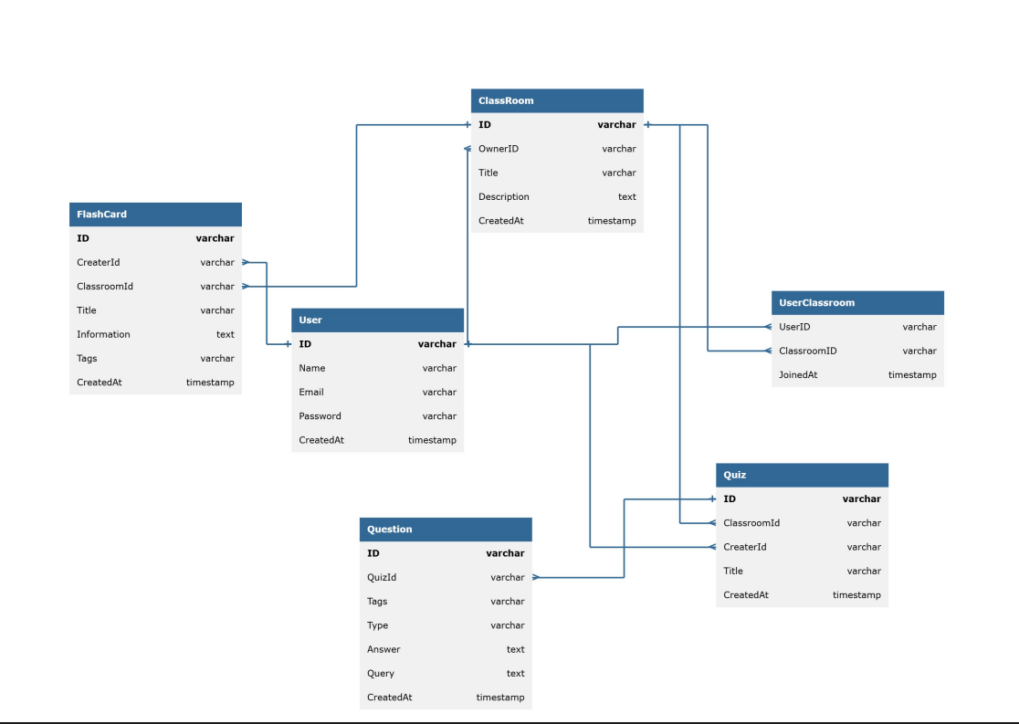
Created a new ERD for the database

